Štěpán Malovec – Olala!
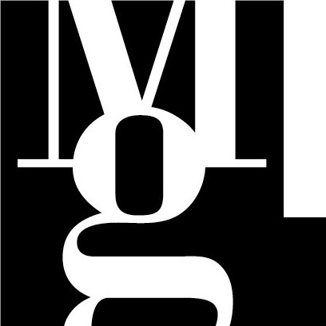
Tisková zpráva Press Release Release
Cloister of the Governor’s Palace, Moravian Gallery in Brno, Moravske nam. 1a, Brno
31 March – 5 June 2005, Opening 31 March at 5 p.m.

CURATOR OF THE EXHIBITION
Marika Kupková

The authorial exhibition of Štěpán Malovec presents a second exhibition in a cloister of Governor’s Palace, which serves, from the beginning of this year, as a new exposition space of a Moravian Gallery in Brno graphic design department. A minute graphic, which is a part of a display POUR FÉLICITER 2005, thus shifts, since the end of March, a selection from the works of the youngest representative of the Czech graphic designers’ generation.
The audience had a chance to get acquainted with posters by Štěpán Malovec already in 2002, under the terms of the 20th International Biennale of Graphic Design. A student in a studio of graphic design and visual communication at the Prague VŠUP at that time obtained Alfos Mucha Prize for a poster there. In an award-winning social poster Coexistence, which chose problems of home violence for its subject matter, he showed ability for a pictorial inventiveness, symbolic signs and ironical exaggeration. All the qualities stated above, are characteristic also for the following Malovec´s projects: cultural posters, invitations and logos. What is also typical for his artistic expression is an application of disposed photography, which is accomplished in a dense up to sharp colouring.
One of the outstanding graphic acts of Štěpán Malovec is his dissertation from 2003, which consists of three interconnected circles: visual style of the world hockey championship, visual style of the Czech national hockey team (including outfit) and the information system of a hockey arena. This unstintingly conceived design of Malovec, which was honoured a dean prize of VŠUP, was not, however, carried out, but it stirred up a commission of Czech television for creating a prize for EHL recruit. The statuette created in cooperation with a sculptor Zdeněk Ruffer, brought a witty point right into the choice of its material – ice, which will melt right after having been awarded to the winner.
The author himself also participated in the realization of the exhibition in a cloister: by creating the design of invitations, posters and even exhibition installation. The exhibition in a cloister is for Štěpán Malovec, a recent assistant in a newly opened studio of graphic design and new media of Petr Babák at VŠUP, is his first exhibition at all; interjection Olala! in its title can be also took in as a joyful cry over its realization.

CONTACT FOR MEDIA
Andrea Poláčková, Press Department MG, tel.: 532 169 174, 737 007 838, tisk@moravska-galerie.cz

